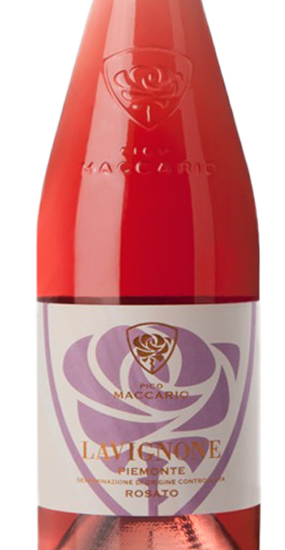DTK is so excited to have this range of wines in our portfolio for Kentucky. Their “Lavignone” Barbera d’Asti quickly became one of most sought-after wine of 2013. The Rosé from the same vineyard (“Lavignone” named after the 200 year old barn at the end of the vineyard).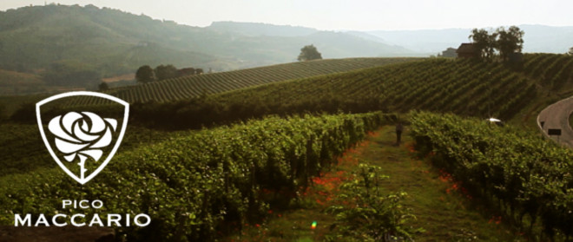

KIND OF WINE

Rosé

LOCATION OF THE TERRAINS

Rolling hills

KIND OF TERRAIN

Pleistocene hills formed from fluvial and river lacustrine deposit

GRAPES

100 % Barbera

CARES IN THE PREPARATION AND REFINEMENT

Manual grape picking.Short contact between must and skins. Rapid separation then white fermentation at 12-13° C

ALCOHOL CONTENT AND TOTAL ACIDITY

12,50% vol - 5,70 g/l

COLOUR

Pale rose

BOUQUET

Intense, full, with relevant flowery notes

FLAVOUR

Smooth, well balanced, silky

BEST SERVED AT

10-12 degrees Celsius

**Wine Bottle Case 2 Cs/BTG 5 Cases**

Lavignone Barbera Rosato $11.30 $132.00 $126.00 $120.00