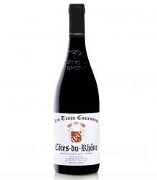

**WHAT A KILLER VALUE!!**

Sometimes we just get lucky, agreed? Frankly speaking, we stumbled onto the little Gem and simply can’t pass it up…

Produced in the beautiful Provence Hamlet of Tulette, this Classy, Plush ripe Grenache and balanced Syrah, centered into the well-structured framework of this CdR will turn heads left and right.

Winemaker’s Tasting Notes:

Les Trois Couronnes Cotes du Rhone is a racy and round wine in the pure tradition, with aromas of black fruits, spices and liquorice. It offers a generous and fleshy mouth with rounded elegant tannins. With a persistent finish of fruits and spices.Best served at 14-15 Celsius.

. **Wine Bottle Case 2 Cs/BTG 5 Cases**

Les Trois Couronnes

Cotes du Rhone Rouge $8.30 $96.00 $90.00 $87.00

