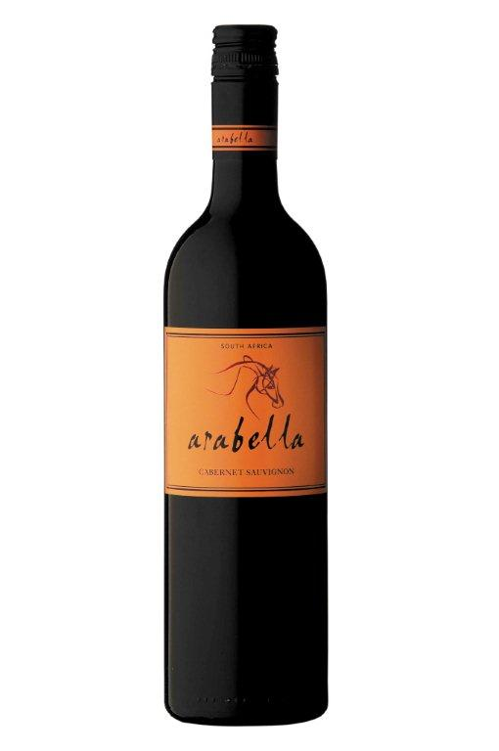**Arabella**

**Cabernet Sauvignon 2011**

Blend Information: 100% Cabernet Sauvignon  
Alcohol: 14% vol  
pH: 3.6  
RS: 3.9 g/l  
Total Acid: 5.4 g/l  
Appellation: Robertson

Tasting Notes*: Brimming with abundant blackcurrant aromas, this full-bodied wine is a mouthful of juicy plum flavors. Delightfully versatile, it makes a delicious partner to a wide variety of foods.*

Beverage Testing Institute Ratings:

2012 World Wine Challenge Best South African Cabernet Sauvignon under $10

World Wine Championships Award: Silver Medal

**Rating: 88 points (Highly Recommended)**

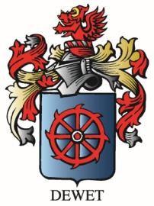“*Red cherry, raspberry, boysenberry, spice and chewy damson plums with vanilla framed oak and a supple palate come together as a soft, but balanced fruit forwards style*”

Vineyard Varieties

Dublin, VA