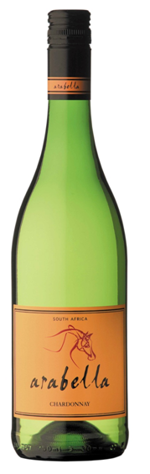**Arabella**

**Chardonnay 2012**

Blend Information: 100% Chardonnay  
Alcohol: 14% vol  
pH: 3.21  
RS: 2.7  
Total Acid: 6 g/l  
Appellation: Robertson

Tasting Notes: *Yellow green in color. Citrus and vanilla on nose and palate. Crisp and elegant with a long finish with subtle hints of wood.*

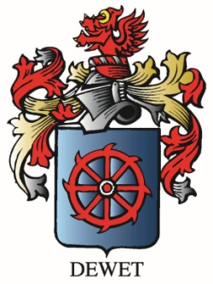

Vineyard Varieties

Dublin, VA