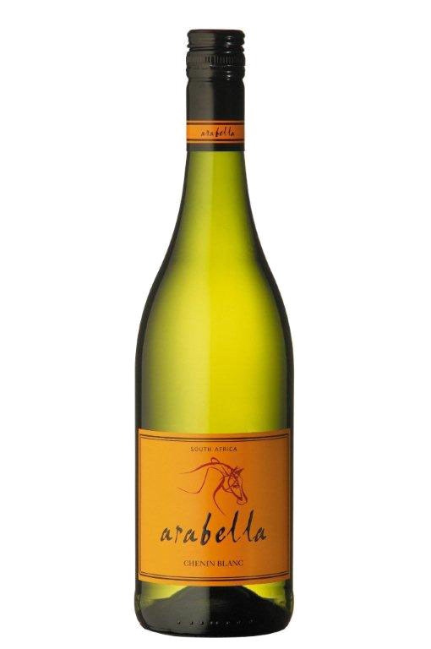**Arabella**

**Chenin Blanc 2012**

Blend Information: 100% Chenin Blanc  
Alcohol: 13% vol  
pH: 3.41  
RS: 1.2 g/l  
Total Acid: 5.8 g/l  
Appellation: Robertson

Awards: MichelAngelo – SILVER

Wine Magazine – Best Value

Tasting Notes: *Yellow, lime green color. Guava with hints of fresh straw on nose. Rich, racy and full on middle palate with great finish.*

Beverage Testing Institute Ratings:

*Honeycrisp apples, honeysuckle, mango, papaya and woolen mittens frame a medium-bodied almost dry palate with a medium-long finish. A hint of white flowers adds complexity to the tropical fruit and sweet apples.*

**WORLD WINE CHAMPIONSHIPS AWARD: Silver Medal**

**RATING: 88 points (Highly Recommended)**

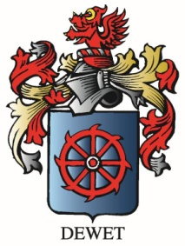

Vineyard Varieties

Dublin, VA