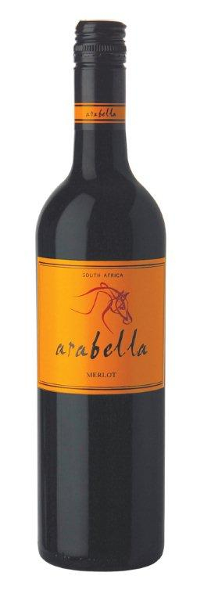**Arabella**

**Merlot 2011**

Blend Information: 100% Merlot  
Alcohol: 14% vol  
pH: 3.6  
RS: 2.6 g/l  
Total Acid: 5.4 g/l  
Appellation: Robertson

Awards: Silver – MichelAngelo

Tasting Notes: *Succulent flavors of ripe plum and blackcurrant, enhanced by hints of coffee and chocolate. Soft tannins lend a firm structure and a long soft finish.*

*Red cherry, boysenberry and red bell pepper with a medium body, soft tannins and a balanced finish. Straightforward sipping wine.*

**WORLD WINE CHAMPIONSHIPS AWARD: Silver Medal**

**RATING: 85 points (Highly Recommended)**



Vineyard Varieties

Dublin, VA