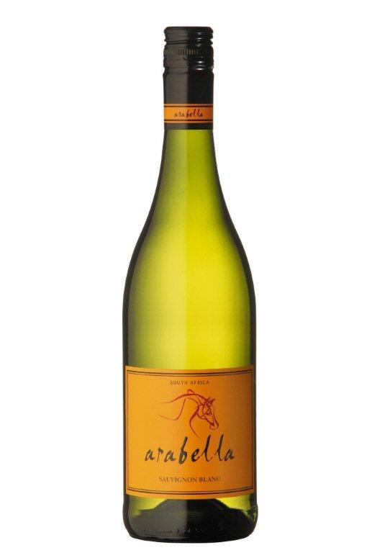**Arabella**

**Sauvignon Blanc 2012**

Blend Information: 100% Sauvignon Blanc  
Alcohol: 13.5% vol  
pH: 3.25  
RS: 1.2 g/l  
Total Acid: 6.1 g/l  
Appellation: Robertson

Awards: 87 pts – Wine Enthusiast Best Buy  
Wine Magazine-2011 Best Value Award

Tasting Notes: *Yellow green in color. Complex green grassy nose with passion fruit, guava and pear aromas. Gooseberry, capsicum and tropical flavors on a full, rich palate with a long sweet-fruited finish.*

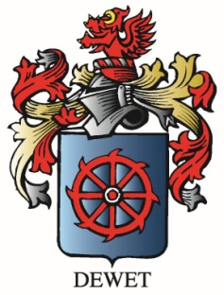

Vineyard Varieties

Dublin, VA