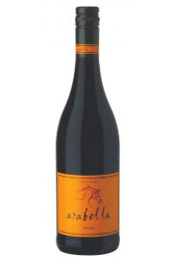**Arabella**

**Shiraz 2011**

Blend Information: 100% Shiraz  
Alcohol: 14% vol  
pH: 3.6  
RS: 3.7 g/l  
Total Acid: 5.4 g/l  
Appellation: Robertson

Tasting Notes: *Deep burgundy red in color with inviting aromas of vanilla and mocha. The palate rewards with lingering flavors of liquorice and ripe black cherries, supported by soft spicy tannins.*

Awards: Double Gold – MichelAngelo  
87 pt s – Wine Enthusiast Best Buy

**'2012 World Value Wine Challenge-Top 10 Red Wine $10 and Under' 2012 WVWC Best South African Shiraz**

**WORLD WINE CHAMPIONSHIPS AWARD: Gold Medal**

**RATING: 91 points (Exceptional)**

*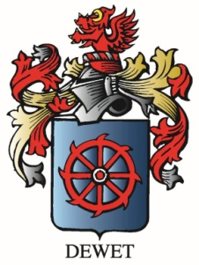Lingonberry, crushed boysenberry, black raspberry, licorice, pomegranate, rhubarb and strawberry compote with a dense fruit cake mid-palate, a touch of cracked pepper and integrate tannins, finish moderately long and balanced ending with inky black licorice and black raspberries.*

Vineyard Varieties

Dublin,VA