**Bourbon, Whiskey, Rye:**

**What’s the difference?**

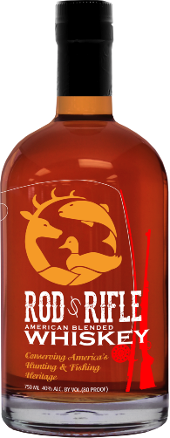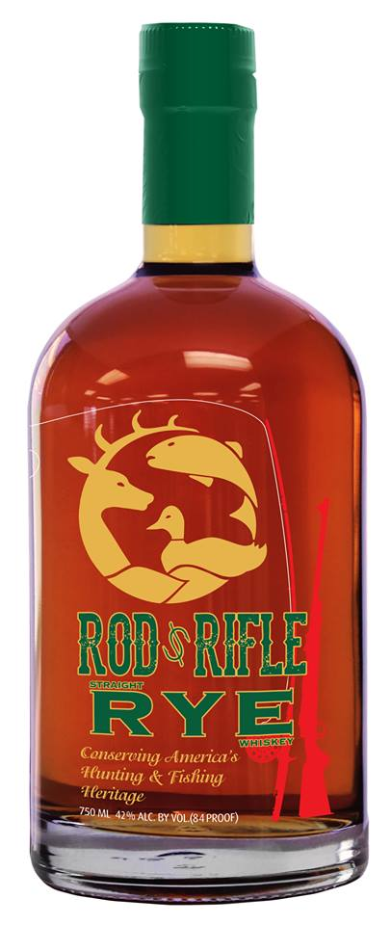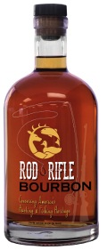**Bourbon**

**All Bourbon is Whiskey but not all Whiskey is Bourbon**

Its mash, the mixture of grains from which the product is distilled, must contain at least 51% corn.

Must be aged in a new charred oak barrel.

To call itself “Straight” Bourbon it must be aged in that barrel for a minimum of 2 years. If aged less than 4 years there must be statement on the bottle that tells how long it was aged for.

To be called a Bourbon is must be from the United States.

**Whiskey**

Whiskey is a distilled spirit made from fermented mash (rye, barley, corn, and wheat)

All whiskeys with the exception of corn whiskey must be aged for some period of time (no minimum) in new charred oak barrels

“Straight” whiskey has been aged for at least 2 years and has not been blended with any other spirits

Must be distilled at a minimum of 40% alcohol by volume

**RYE**

American Rye must be made of a mash from no less than 51% rye.

Must be aged in charred new oak barrels

“Straight” Rye must be aged for a minimum of 2 years

The big difference between rye and bourbon is the taste, Bourbon made of 51% corn, is noticeable sweeter and fuller bodied. Rye made of 51% Rye, is generally spicier and lighter bodied.