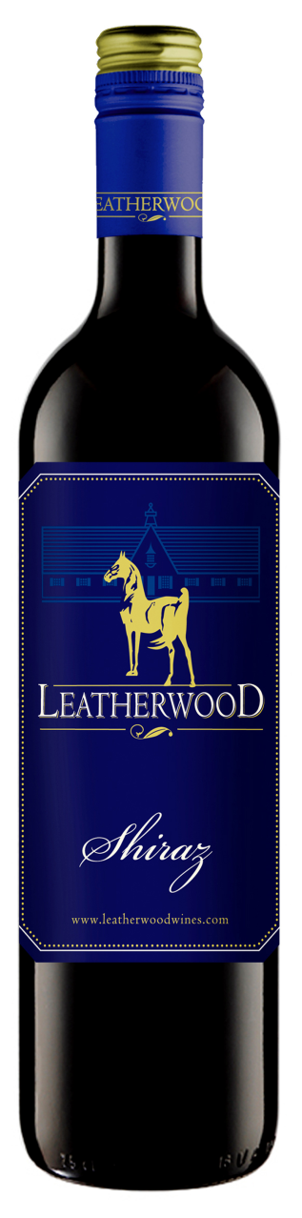Leatherwood

2010 Shiraz

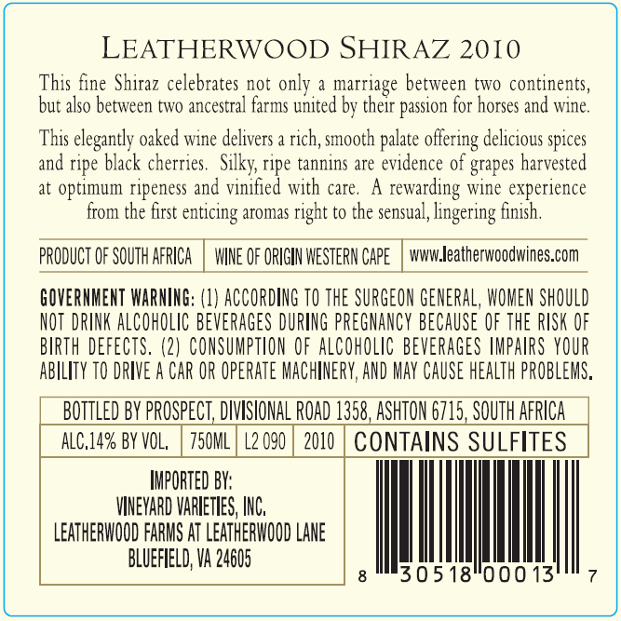

Blend Information: 100% Shiraz  
Winemaker : Chris de Wet  
Alcohol : 14.5% vol  
RS : 5 g/l  
Total Acid : 5.04 g/l  
Balling/Brix : 25°  
Yield : 3.2 tons/acre  
Production : 12,000 cases  
Oak Type : French Barriques  
Oak Age : 100% 3rd and 4th fill  
Time in Oak : 12 months  
Appellation : Western Cape, South Africa  
Harvest date : 2/20/2010

Beverage Testing Institute Ratings:

“*Dried plum, black cherry compote and raisins with dark fruit on the mid-palate and finish. Dried fruit is driving the palate with soft tannins and good balance*.”

* World Wine Championships Award: Silver Medal
* **Rating: 87 points (Highly Recommended)**



Vineyard Varieties

Dublin, VA