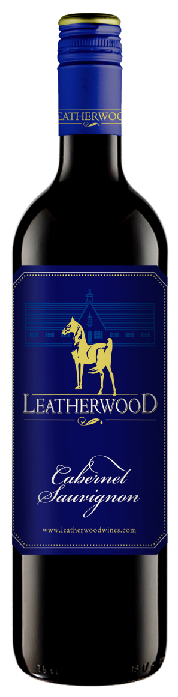Leatherwood

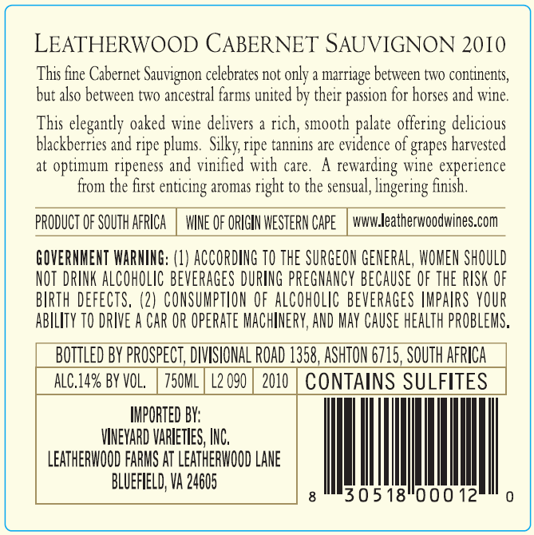2010 Cabernet Sauvignon

Blend Information: 100% Cabernet Sauvignon  
Winemaker : Chris de Wet  
Alcohol : 14% vol  
RS : 5.5 g/l  
Total Acid : 5.04 g/l  
Balling/Brix : 24.3°  
Yield : 4.8 tons/acre  
Production : 18,000 cases  
Oak Type : French Barriques  
Oak Age : 80% 3rd and 4th fill; 20% new  
Time in Oak : 12 months

Harvested: 3/8/2010  
Appellation : Western Cape, South Africa

Tasting Notes: This fine Cabernet Sauvignon celebrates not only a marriage between two continents but also between two ancestral farms united by their passion for horses and wine.

This elegantly oaked wine delivers a rich, smooth palate offering delicious blackberries and ripe plums. Silky, ripe tannins are evidence of grapes harvested at optimum ripeness and vinified with care.

A rewarding wine experience from the first enticing aromas right to the sensual, lingering finish.

**Awards: 87 pts – Wine Enthusiast**

*Reviews: The Leatherwood Cabernet is a rich, velvety sip with aromas of plum, black currant and spice, and flavors of blackberry, tobacco and spice. Integrated and balanced with a fruity overall character, the wine is both elegant and pronounced. S.K. (12/31/2009) – 87 2010 Wine Enthusiast Magazine*

Beverage Testing Institute Ratings:

*Damson plum, red cherry, lingonberry, and strawberry with a touch of bell pepper and vanilla lead to a medium body with integrated tannins and a moderate finish*

* 2012 World Value Wine Challenge Best South African Cabernet Sauvignon under $15
* World Value Wine Championships Award: Silver Medal
* Rating: **87 points (Highly Recommended)**

Vineyard Varieties

Dublin, VA