**- - - Awesome French Bubbles - - -**

**Louis Perdrier Sparkling Wines**

**Since 1780, the Patriarche family has been at the heart of Burgundy!**

K

iller, killer, killer & at amazing prices! We could leave it at that, but it wouldn’t be fair… we were tasting several possible bubbles to represent earlier this fall and thought we’d found some winners. We poured up the next wine (Louis Perdrier Brut Excellence) while looking for pricing. One of us declared, “well, we’ve certainly stepped up in price on this one.” Shockingly, it was the same price range as what had just been excited about. The excitement continued as we went on through the Rose and at a sick price. Be prepared to have fun with Bubbles again.

**FAMILY HISTORY…**

T

he Patriarche family started offering the world amazing wines of Burgundy over 230 years ago. They’re continued passion and commitment to families, loyalty, Human values and forward thinking open-mindedness has never waned. Today, their legacy is a guarantee of authenticity that perpetuates their legends through products that have benefited from all their know-how.

**THE SUCCESS OF BUBBLES…**

T

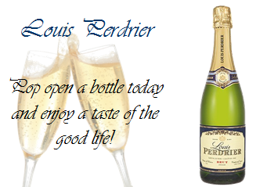he tradition of Crémant de Bourgogne in Burgundy goes back to the 19th century. As heir to this know-how, Patriarche produces sparkling wines that benefit from our creativity and know-how. Selection, blending, fermentation, effervescence or "*prise de mousse*", addition of sugar or "*dosage*" and filtration are all steps that determine the final quality of the product. In the 1950s, Patriarche was the pioneer in sparkling wines with the launch of the KRITER brand whose success has never waned. Patriarche's celebratory wines include AOC Cremant de Bourgogne wines, terroir wines, and elegant, classy wines whose tradition dates back to the early 19th century in Burgundy. Today, Patriarche is the second largest producer of sparkling wine in France, which proves its great success in this category. Patriarche's sparkling wines are among the finest in their category and are exported worldwide.

**MORE TO COME FROM PATRIARCHE…**

I

n 2012, we are looking intently to Patriarche for access to amazing Burgundian table wines from all of the great villages, and many of the best vineyards that Burgundy can offer. We will give you all notice as the time comes closer to introduce you to them. Stay tuned.