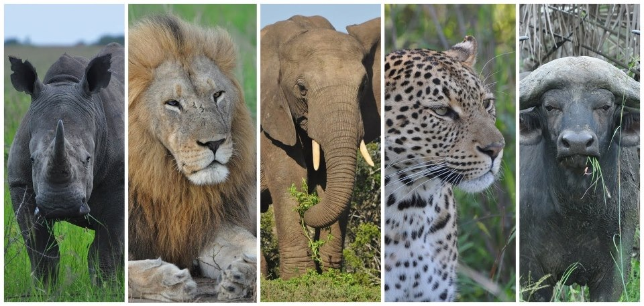**FIVE’S RESERVE MARULA CRE AM**

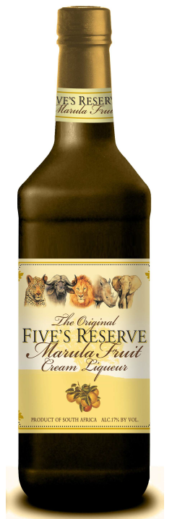

Five’s Reserve Marula is a unique cream liqueur created by South Africa's most famous master liqueur maker, who has produced some of the most famous liqueur in the world.   
  
Crafted to perfection through passion, and using only the finest ingredients, the result, a perfectly balanced, yet slightly wild exotic cream liqueur, captivating the true essence of Africa. The wild African Baobab tree…mysterious and enchanting…as old as Africa itself was the inspiration behind the creation of the unique, all natural cream liqueurs and cocktails.

Enjoy this drink chilled, on ice, or mixed in your favorite cocktail. Sit back, relax and taste this wonderful experience!

17% Alcohol by volume

Origin: Robertson, South Africa

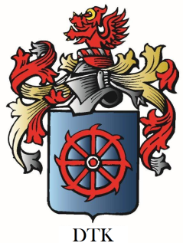

**De Wet’s Toast of Kentucky**

**4223 Lexington Rd, Suite J**

**Paris, KY 40362**