

DTK is so excited to have this range of wines in our portfolio for Kentucky. a string of accolades to grab consumers’ attention before the Wines’ beauty, class and stunning flavors solidify the loyalty. Named after the highest mountain in Marlborough, The Ned, and was the childhood “play ground” for Owner and Winemaker Brent Marris. This backdrop, is now the site of Brent’s dream started in 2003 and launched in 2005 upon his departure after 20 years as Chief Winemaker for Oyster Bay. Immediate success followed. WinesfromMariscoVineyards’WaihopaiValleypropertyhavenowwon55goldmedalsandninetrophiesoverthepastthreeyears.Lastmonththecompanywon ten double--‐gold andgoldmedalsattheChinaWineAwards,aswellasthetrophy forNewZealandWineProduceroftheYear.

[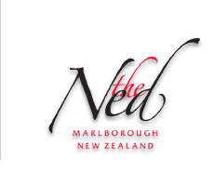](http://thened.co.nz/)

The Stunning package and shipper designs are from Brent’s partnering with world-renown Fashion Designer, Trelise Cooper. Ms. Cooper’s garments are favorites of the Hollywood Elite and The Best Dressed Women in the World. Quality, Style and Class is her Calling Card. Partnering with like-minded people is vital to successful business and life is one of Brent’s mantras. We’re sure that you’ll agree that these are the Real Deal, the Complete Package… Taste, Feature, Stack and watch the Smiles from your Customers and Guests.

. **Wines Bottle Case 2 Cs/BTG 5 Cases**

The Ned

Sauvignon Blanc $12.30 $144.00 $135.00 $126.00

Pinot Gris $12.30 $144.00 $135.00 $126.00

Pinot Noir $16.00 $186.00 $177.00 $171.00