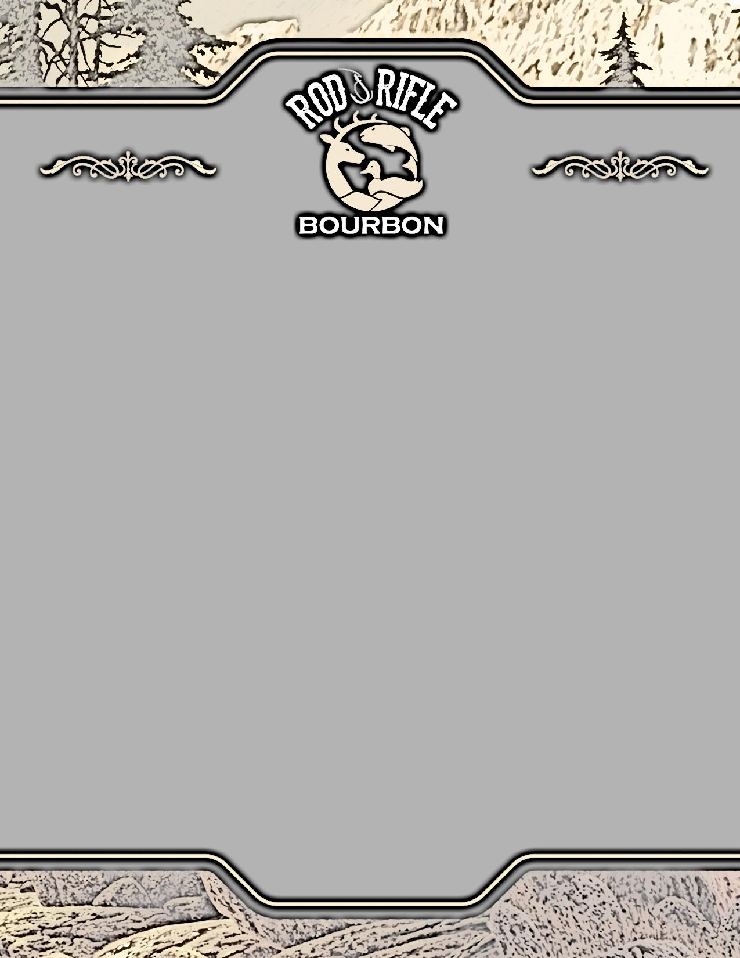

**Purchase Includes**

2013 Shot Glass

4 Year Old Bourbon

$50 Bucks / Ducks Cash

Contribution Wildlife Forever

**Specifications**

Bottle Size: 750 ml

Bottles per Case: 12

Cases per Pallet: 60

Case Weight: 37 LBS

80 Proof / 40% ALC/VOL

Btl UPC: 634650070801

Case UPC: 0634650070801

**Distributed By:**

**De Wet’s Toast of Kentucky**

Office: (859) 340-1715

**Collector Shot Glass**2013 / White Tail Deer 2014 / Large Mouth Bass

2015 / Mallard Duck

2016 / American Turkey

2017 / Walleye

**On Premise Pricing**

**2 Bottles: $24.00**

**4 Bottles: $22.50**

**Case: $252.00**

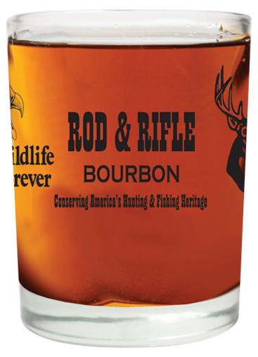

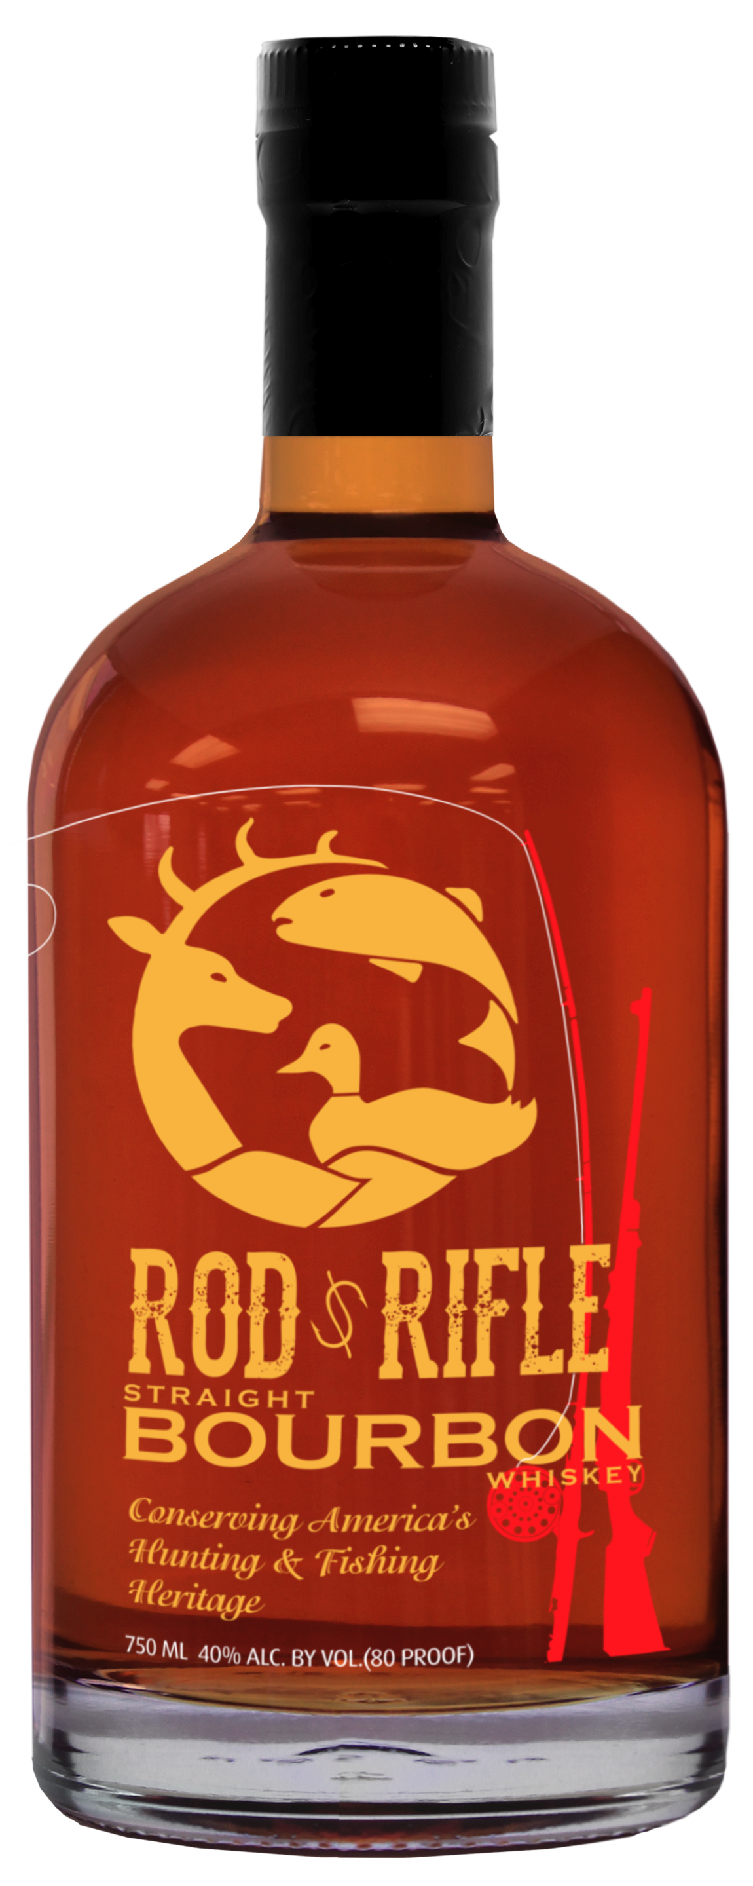

MC900436718[1]

**Conserving America's Hunting & Fishing Heritage**

Rod & Rifle Bourbon is an 80-proof straight bourbon with a smooth, rich and balanced taste profile. Rod & Rifle Bourbon is custom formulated using the finest quality mash bill of 70% Corn, 25% Rye, and 5% Malted barley. We first distill Rod & Rifle using a time honored copper still. The double distilled bourbon is then aged to perfection in newly charred barrels of American Oak for 48 months.

**Marketing Partners**

Outdoor Channel

North American Media

First Light Production

Over 5,000 Rod & Rifle Clubs

Social Media

**Resident Licenses**

291,000 Registered Hunters

721,911 Registered Fisherman

1,475,000 Wildlife Watchers

$34 Billion Spent Hunting

$46 Billion Spent Fishing

