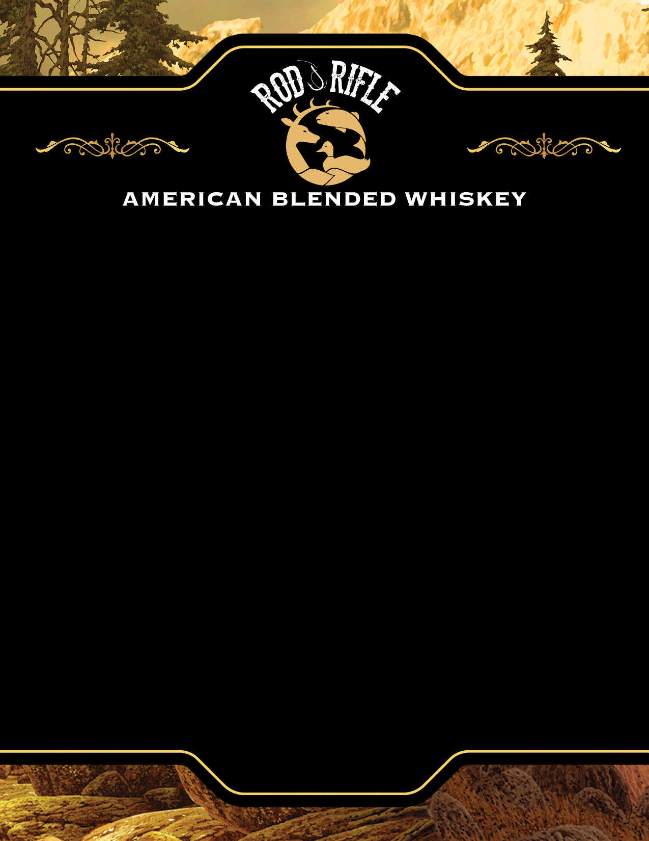

MC900436718[1]

**Retail Pricing**

**3 Bottles: $16.80**

**6 Bottles: $15.80**

**1 Case: $180.00**

**3 Cases: $168.00**

**Distributed By:**

De Wet’s Toast of Kentucky

Office: (859) 340-1715

**Resident Licenses**

291,000 Registered Hunters

721,000 Registered Fishermen

1,475,000 Wildlife Watchers

$34 Billion Spent Hunting

$46 Billion Spent Fishing

**Specifications**

Bottle Size: 750 ml

Bottles per Case: 12

Cases per Pallet: 60

Case Weight: 39 LBS / Pallet

Weight: 2,355 LBS

80 Proof / 40% ALC/VOL

Btl UPC: 634650070702

Case UPC: 0634650070702

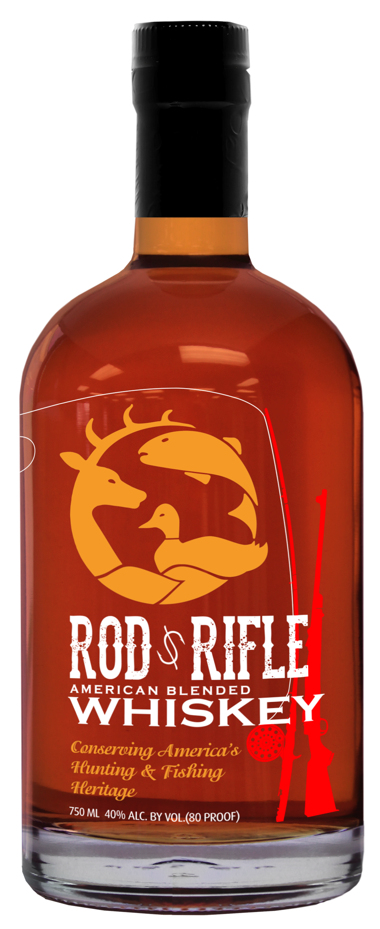

**Marketing Partners**

Outdoor Channel

North American Media

First Light Production

Over 5,000 Rod & Rifle Clubs

Social Media

**Purchase Includes**

100% Aged Whiskey

$25 Bucks / Ducks Cash

Contribution Wildlife Forever

**Conserving America's Hunting & Fishing Heritage**

Rod & Rifle Bourbon American Blended Whiskey is distilled, aged and bottled to create a high quality 80-proof whiskey for outdoor enthusiasts. Our whiskey combines small town, time honored tradition for a rich and balanced taste. Our whiskey is perfect straight or mixed into your favorite drink after a great day of hunting, fishing or shooting. We have spared no expense in bringing Rod & Rifle American Blended Whiskey to your home, hunting or fishing cabin. Please always Hunt, Fish Shoot and Drink Responsibly.