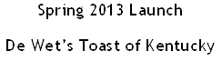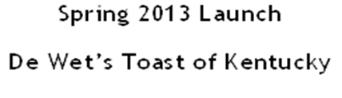

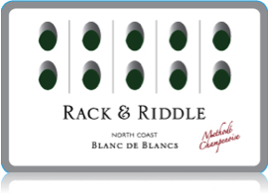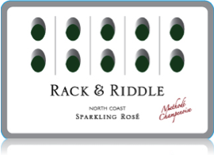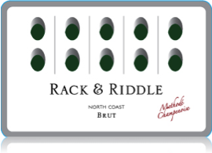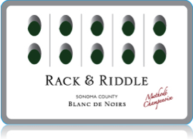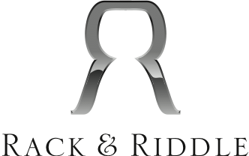

**R&R Brut**

*North Coast*

60% Chardonnay, 40% Pinot Noir, 1.15% water dosage, 9 months on tirage

Citrus, Pear, & floral aromas with a hint of yeast. The fine mousse brings forth the light citrus, smooth and round in the mouth. Finish is round, with a note of grapefruit.

**R&R Blanc de Blanc**

*North Coast*

100% Chardonnay, 1.15% water dosage, 8 months on tirage

Beautiful green apple and tropical notes in the aroma follows through in the mouth with a smooth fine mousse. This wine finishes with lingering light tropical flavors.

**R&R Sparkling Rose**

*North Coast*

50% Chardonnay, 50% Pinot Noir, 1.2% water dosage, 10 months on tirage

Ripe strawberry with a hint of cream and spice. The mouth is round, with creaminess from the fine mousse. The bright, fresh fruit is followed to the finish-crisp and clean.

**R&R Blanc de noir**

*Sonoma County*

92% Pinot Noir, 8% Chardonnay, 1.2% water dosage, 26 months on tirage

Brioche and a hint of berry, with bright citrus in the aromas. The fine mousse brings along these notes in the mouth. Lingering finish of citrus that begs for another taste.

**Brut & Blanc de Blanc**

**Bottle: $16.50; Case: $192.00; 2cs/BTG: $183.00; 5cs: $174.00**

**Rose & Blanc de Noir**

**Bottle: $18.50; Case: $216.00; 2cs/BTG: $204.00; 5cs: $192.00**